[accent_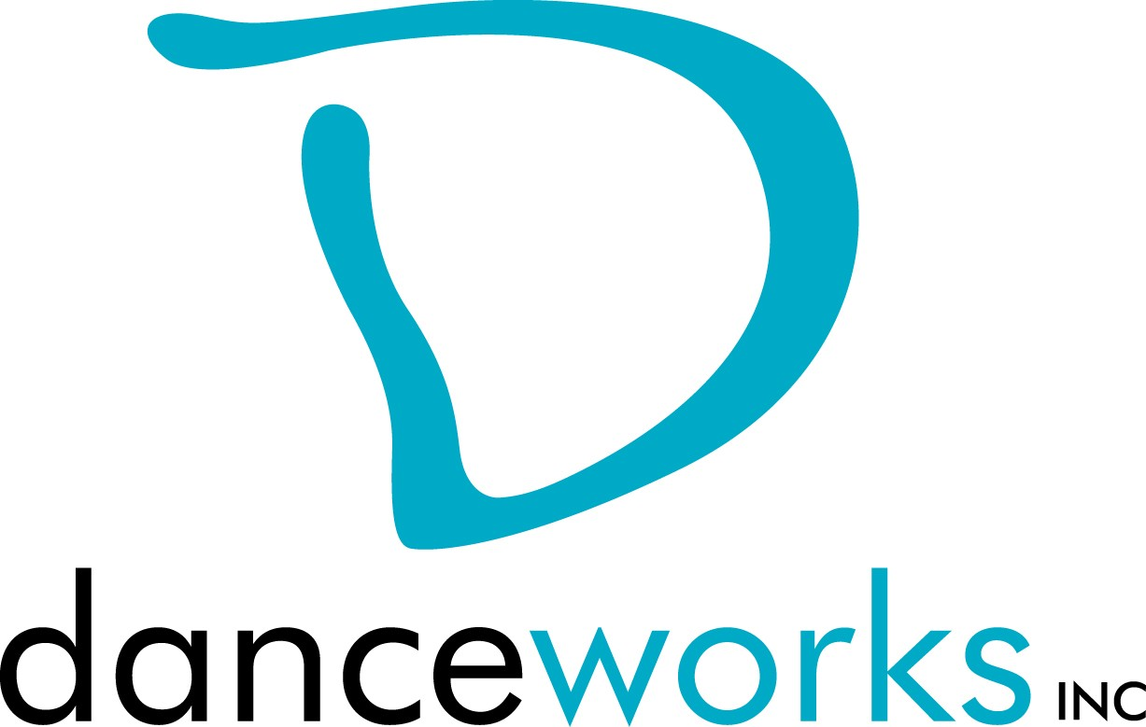

MOVEMENT MEDIA LAB
DanceLAB Series 2019 Call For Participation

Are you currently working on a dance film, or looking to begin a new project with movement as the main component? DanceLAB Series is calling for artists and filmmakers working with dance/movement to submit their ideas or works in progress for Movement Media Lab 2019.

Film or video in any genre (experimental, narrative, documentary, or animation) will be considered. The definition of dance and movement is broad, and all forms including but not limited to post modern, modern, world, tap, ballet, and hip-hop are encouraged to apply. The Movement Media Lab invites conversation about the process in translating choreography to the camera, the relationship to the body in a 2D format, and the unique ability to highlight movement through camera work and editing. The Lab also looks to connect diverse audiences and communities through movement and film/video. Selected artists will show their finished works on Saturday September 28, 2019 at Danceworks Studio Theatre.

All artists will meet for one work-in-progress group critique. The in-progress critique will take place on Thursday, August 15, 2019 at 6pm. The critique will take place on UW-Milwaukee’s campus, in Mitchell Hall, classroom B65. All artists and their collaborators will be expected to show a rough cut of their work at this time. Accepted artists may request further mentoring from the production manager at any time during the creation/rehearsal process.

Interested artists are required to submit written proposals and biographical information to Danceworks on or before Monday, June 3, 2019 using the attached proposal form.

Accepted artists and their performing cast members will be eligible to take 2 Danceworks studio classes/week for free from the date of acceptance through September 28, 2019. Limited studio space will also be available for rehearsals at no charge to artist up to 3 hours a week.

Please contact Kym McDaniel for more information at kmcdaniel@danceworksmke.org or Danceworks at (414) 277-8480.

Movement Media Lab Timeline:
May 7: Call for Participation
June 3: Proposals due to Danceworks
June 10: Artists receive notification regarding acceptance
June 12, 6pm: Required meeting at Danceworks with accepted artists August 15, 6pm: In-progress critique – Mitchell Hall B65
September 28: 8:00pm Screening

MOVEMENT 2019 PROPOSAL FORM
Proposals are due on or before Monday, June 3, 2019. Please submit electronic or hard copy to Kym McDaniel, c/o Danceworks, 1661 N. Water St., Milwaukee, WI 53202 or email to kmcdaniel@danceworks.org. Please contact Danceworks at (414) 277-8480 ext. 6018 with questions or concerns or via email at the email address listed above. Only artists whose proposals are submitted by the deadline will be considered. Artists will be notified of their acceptance into the Movement Media Lab on or before Monday, June 10, 2019.

ELIGIBILITY: Filmmakers must be 18 years of age or older.

CRITERIA: Works must not greater than 10 minutes. Work must not consist of profanity or crude subject matter.

INSTRUCTIONS: Please respond to the items below to the best of your ability. In addition to completing this form, please attach a bio (75 words or less). Any supporting materials (work samples, etc.) can be dropped off or attached but are not required. The quality of the proposal will be taken into consideration.

ARTIST(S): ADDRESS:

PHONE: EMAIL: BIO:

What is the intention of your piece?

Special requirements (if any):

Any additional comments about you or your work:

Why are you interested in being a part of this performance? How did you find out about the Movement Media Lab?

