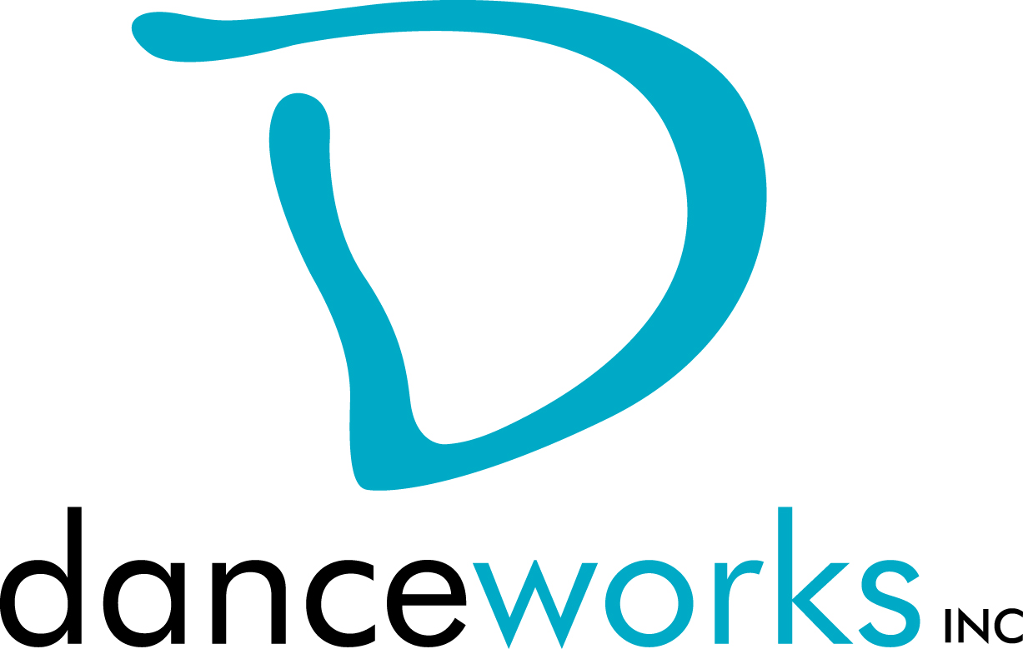
GET IT OUT THERE
DanceLAB Series 2019-2020
Call For Participation

Do you have work that you want to get out there? Would you like to get feedback on it? What about meeting other artists in hopes of collaborating? GET IT OUT THERE is a concert featuring new work created by Milwaukee performing artists from various disciplines. Selected artists will showcase their work on Saturday, October 12, 2019 at Danceworks Studio Theatre. Danceworks provides production support including sound and minimal light design. This performance is presented through the DanceLAB concert series.

Interested artists are required to submit written proposals and biographical information to Danceworks on or before Monday, June 24, 2019, using the attached proposal form.

Accepted artists and their performing cast members will be eligible to take 2 Danceworks studio classes per week for free, with the exception of certain workshops, from the date of acceptance through October 12, 2019. Limited studio space will also be available for rehearsals at no charge to artist up to 3 hours a week.

Accepted artists presenting work for the first time in a DanceLAB concert are required to schedule a feedback session with the production manager. Accepted Artists that have participated in previous DanceLAB concerts may request mentoring from the production manager at any time during the creation/rehearsal process. All artists will be expected to submit a video link to show completed work, or work in-progress no later than Friday, October 4, 2019.

Please contact Gina Laurenzi for more information at glaurenzi@danceworksmke.org

GET IT OUT THERE Timeline
(Danceworks reserves the right to edit the production schedule as needed)

Monday, June 3 Call for Participation
Monday, July 1 Proposals due to Danceworks
Friday, June 28 Artists receive notification regarding acceptance into performance
Tuesday, October 1 Video submission of work and program notes due
Friday, October 4 Final Music submission due

October 6-10 Tech Rehearsal (each piece will need to attend 1, 25-minute tech)
October 11 Mandatory Dress Rehearsal; 7:45pm -10:00pm

October 12 Call for Performers SHOW A; 5:00pm
October 12 Performance – SHOW A; 6:00pm
October 12 Call for Performers SHOW B; 7:00pm
October 12 Performance – SHOW B; 8:00pm

Please contact Gina Laurenzi for more information at glaurenzi@danceworksmke.org

GET IT OUT THERE 2019 PROPOSAL FORM

Proposals are due on or before Monday, June 24, 2019. Please submit electronic copy to Gina Laurenzi at glaurenzi@danceworksmke.org. Only artists whose proposals are submitted by the deadline will be considered. Artists will be notified of their acceptance into GET IT OUT THERE on or before Friday, June 28, 2019. Those submitting proposals must be 18 years or older.

CRITERIA:
Work must be a minimum of 3 minutes and not greater than 10 minutes. Work must not consist of profanity, nudity, or crude subject matter. Proposals must fit flexibly into project parameters (including limited rehearsal time and technical support).

INSTRUCTIONS:
Please respond to the items below to the best of your ability. In addition to completing this form, please attach a bio (75 words or less). Any supporting materials (work samples, etc.) can be included with proposal, but are not required. The quality of the proposal will be taken into consideration.

ARTIST:

ADDRESS:

PHONE: EMAIL:

ART DISCIPLINE:

BIO:

Number of performers: ____
Length of work:_____
Additional elements you’d like to mention (i.e. costume/set design):

Special requirements (if any):

What is the intention of your piece?

Any additional comments about you or your work:

Why are you interested in being a part of this performance?

How did you find out about GET IT OUT THERE?

