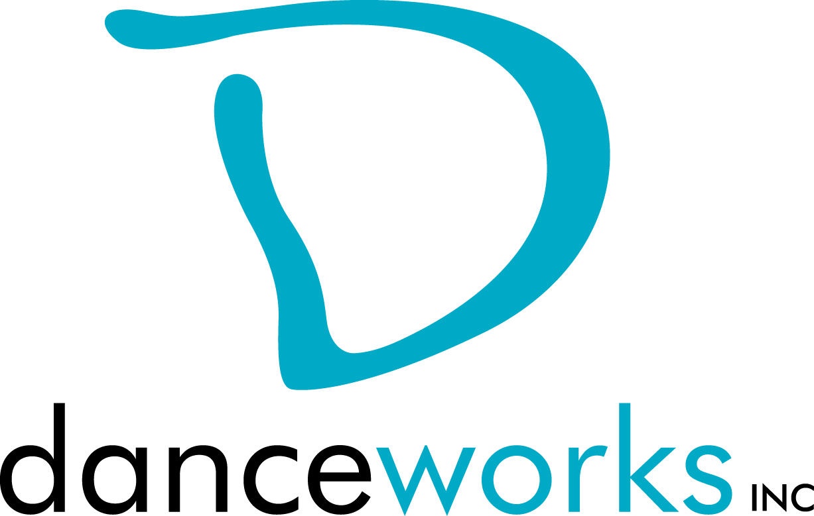
IGNITE: A HIP HOP DANCE EXPERIENCE
Call For Participation
Danceworks recognizes the passion, commitment, and artistry of the area’s hip hop dance crews and other percussive dance art forms. We would like to showcase this exciting work as a part of our Summer DanceLAB Concert Series - Ignite: A Hip Hop Dance Experience. Selected artists will showcase their work on Saturday, July 28, 2018 at 6:00pm & 8:00pm, and Sunday, July 29, 2018 at 6:00pm at Danceworks Studio Theatre. Danceworks provides production support, including sound and minimal light design.
Interested artists are required to submit written proposals and biographical information to Danceworks on or before, May 4, 2018 using the attached proposal form.
Please contact Danceworks Managing Director, Kim Johnson for more information at kjohnson@danceworksmke.org or at (414) 277-8480 ext. 6018.
IGNITE: A HIP HOP DANCE EXPERIENCE Timeline:
April 4: Call for Participation
May 4: Proposals due to Danceworks via email or drop off at front desk
May 7: Artists receive notification regarding acceptance into performance
June 28: Check In - Video submission of work due to Production Manager
July 11: Option #1, 7:50-9:00pm Production Meeting with Lighting Designer
July 18: Option #2, 7:50-9:00pm Production Meeting with Lighting Designer
July 19: Video and music submission of piece due to lighting designer
July 22 – July 26: Tech Rehearsals (each piece will attend one, 30-minute tech rehearsal with the lighting designer)
July 27: 7:50-10pm, Mandatory Dress Rehearsal
July 28: 5:00pm Call for Performers
July 28: 6:00pm Performance #1 and 8:00pm Performance #2
July 29: 5:15pm Call for Performers
July 29: 6:00pm Performance #3

IGNITE: A HIP HOP DANCE EXPERIENCE 2018 PROPOSAL FORM
Proposals are due on or before Friday, May 4, 2018. Please submit electronic or hard copy to Kim Johnson, c/o Danceworks, 1661 N. Water St., Milwaukee, WI 53202 or kjohnson@danceworksmke.org. Only artists whose proposals are submitted by the deadline will be considered. Artists will be notified of their acceptance into IGNITE: A HIP HOP DANCE EXPERIENCE on or before Monday, May 7, 2018. Each crew selected will be given a $125 stipend, receive 2 free classes a week (May 8 – July 31), and receive up to 3 hours of studio space to rehearse depending on availability at no cost. Additional rehearsal hours will be available at a very reduced cost. Please contact Kim Johnson at (414) 277-8480 ext. 6018 with questions or concerns or via email: kjohnson@danceworksmke.org.
CRITERIA:
WORK MUST BE A MINIMUM OF 5 MINUTES and not exceed 10 minutes in length. Both choreography and music may not include profanity or nudity. Proposals must fit flexibly into project parameters (including limited rehearsal time and technical support).
Age Requirement: Performers must be a minimum of 16 years of age.
INSTRUCTIONS:
Please respond to the items below to the best of your ability. In addition to completing this form, include a bio (75 words or less). Any supporting materials (work samples, etc.) can be dropped off or attached but are not required. The quality of the proposal will be taken into consideration.

ARTIST:

ADDRESS:

PHONE:
EMAIL:

Number of performers:
Anticipated length of work:
Additional elements you’d like to mention (i.e. costume/set design):

Special technical requirements (if any):

Why are you interested in being a part of this performance?

What is the intention/theme of your piece?

How did you find out about IGNITE: A HIP HOP DANCE EXPERIENCE?

Please list a link(s) to any previous choreography and/or a list of performances your choreography has been showcased at.

