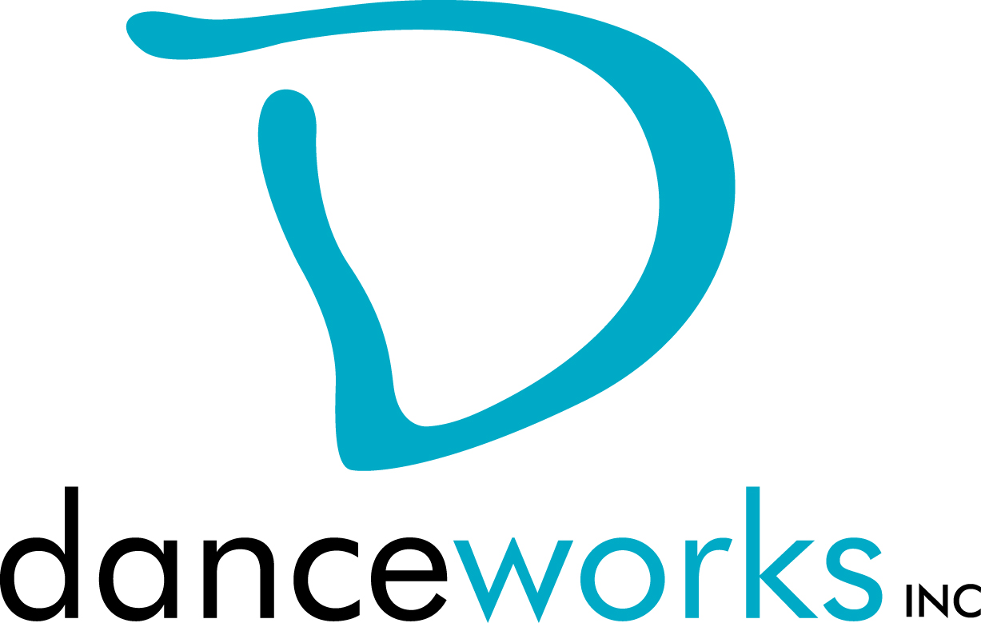
GET IT OUT THERE
DanceLAB Series 2018
Call For Participation

Do you have work that you want to get out there? Would you like to get feedback on it? What about meeting other artists in hopes of collaborating? GET IT OUT THERE is a concert featuring new work created by Milwaukee performing artists from various disciplines. Selected artists will showcase their work on Saturday, January 20, 2018 at Danceworks Studio Theatre. Danceworks provides production support including sound and minimal light design. This performance is presented through the DanceLAB concert series.

Interested artists are required to submit written proposals and biographical information to Danceworks on or before Tuesday, November 21, 2017 using the attached proposal form.

Accepted artists and their performing cast members will be eligible to take Danceworks studio classes for free, with the exception of certain workshops, from the date of acceptance through January 31, 2018. Limited studio space will also be available for rehearsals at no charge to artist up to 3 hours a week.

Accepted artists presenting work for the first time in a DanceLAB concert are required to schedule a feedback session with the production manager. Accepted Artists that have participated in previous DanceLAB concerts may request mentoring from the production manager at any time during the creation/rehearsal process. All artists will be expected to submit a video link to show completed work, or work in-progress no later than January 4, 2018.

Please contact Danceworks Senior Programs Director, Kim Johnson for more information at kjohnson@danceworksmke.org or at (414) 277-8480 ext. 6018.

GET IT OUT THERE Timeline (Danceworks reserves the right to edit the production schedule as needed.)
October 23 Call for Participation
November 21 Proposals due to Danceworks
November 22 Artists receive notification regarding acceptance into performance
January 4 Video submission of work and program notes due
January 11 Music submission due

January 15-18 Tech Rehearsal (each piece will need to attend 1,
25-minute tech)
January 19, 7:45 -10:00pm Mandatory Dress Rehearsal
January 20, 5:00pm Call for Performers
January 20, 6:00pm Performance #1
January 20, 8:00pm Performance #2

GET IT OUT THERE 2018 PROPOSAL FORM

Proposals are due on or before Tuesday, November 21, 2017. Please submit electronic or hard copy to Kim Johnson, c/o Danceworks, 1661 N. Water St., Milwaukee, WI 53202 or kjohnson@danceworksmke.org. Please contact Kim Johnson at (414) 277-8480 ext. 6018 with questions or concerns or via email at the email address listed above. Only artists whose proposals are submitted by the deadline will be considered. Artists will be notified of their acceptance into GET IT OUT THERE on or before Wednesday, November 22, 2017.

ELIGIBILITY:
Performing artists must be 18 years of age or older.

CRITERIA:
Work must be a minimum of 3 minutes and not greater than 10 minutes. Work must not consist of profanity, nudity, or crude subject matter. Proposals must fit flexibly into project parameters (including limited rehearsal time and technical support).

INSTRUCTIONS:
Please respond to the items below to the best of your ability. In addition to completing this form, please attach a bio (75 words or less). Any supporting materials (work samples, etc.) can be dropped off or attached but are not required. The quality of the proposal will be taken into consideration.

ARTIST:

ADDRESS:

PHONE: EMAIL:

ART DISCIPLINE:

BIO:

Number of performers: ____
Length of work:_____
Additional elements you’d like to mention (i.e. costume/set design):

Special requirements (if any):

What is the intention of your piece?

Any additional comments about you or your work:

Why are you interested in being a part of this performance?

How did you find out about GET IT OUT THERE?

