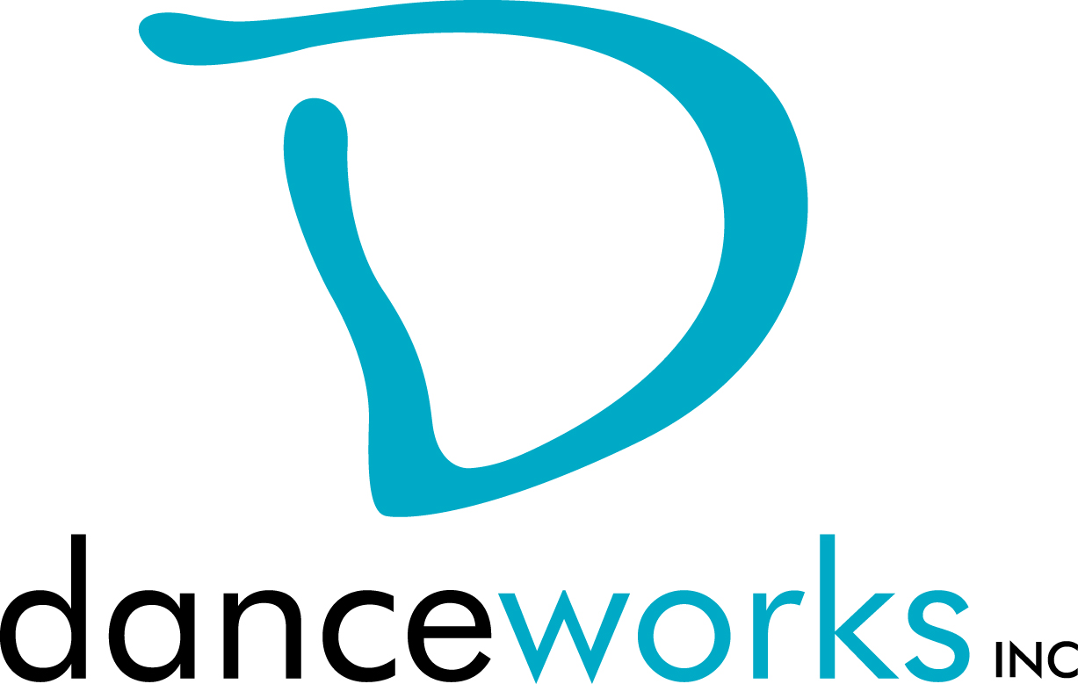
GET IT OUT THERE
DanceLAB Summer Series 2017
Call For Participation

Do you have work that you want to get out there? Would you like to get feedback on it? What about meeting other artists in hopes of collaborating? GET IT OUT THERE is a concert featuring new work created by Milwaukee performing artists from various disciplines. Selected artists will showcase their work on Saturday, September 16, 2017 at Danceworks Studio Theatre. Danceworks provides production support including sound and minimal light design. This performance is presented through the DanceLAB concert series.

Interested artists are required to submit written proposals and biographical information to Danceworks on or before Thursday, July 6, 2017 using the attached proposal form.

Accepted artists and their performing cast members will be eligible to take Danceworks studio classes for free from the date of acceptance through September 30, 2017. Limited studio space will also be available for rehearsals at no charge to artist up to 3 hours a week.

Accepted Artists may request mentoring from the production manager at any time during the creation/rehearsal process.

Please contact Danceworks Artistic Manager, Kim Johnson for more information at kjohnson@danceworksmke.org or at (414) 277-8480 ext. 6018.

GET IT OUT THERE Timeline:
June 7 Call for Participation
July 6 Proposals due to Danceworks
July 10 Artists receive notification regarding acceptance into
Performance
September 9 Video submission of work and music due to
Lighting Designer

September 11, 8:40-10:00pm Tech Rehearsal (*each piece will need to attend one of the 25-minute tech rehearsals)
September 13, 8:45-10:00pm Tech rehearsal continued
September 14, 7:00-10:00pm Tech rehearsal continued
September 15, 1:00-3:30pm Tech rehearsal continued
September 15, 7:45-10:00pm Mandatory Dress Rehearsal
September 16, 4:45pm Call for Performers
September 16, 6:00pm Performance #1
September 16, 8:00pm Performance #2

GET IT OUT THERE SUMMER 2017 PROPOSAL FORM

Proposals are due on or before Thursday, July 6, 2017. Please submit electronic or hard copy to Kim Johnson, c/o Danceworks, 1661 N. Water St., Milwaukee, WI 53202 or kjohnson@danceworksmke.org. Please contact Kim Johnson at (414) 277-8480 ext. 6018 with questions or concerns or via email at the email address listed above. Only artists whose proposals are submitted by the deadline will be considered. Artists will be notified of their acceptance into GET IT OUT THERE on or before Monday, July 10, 2017.

ELIGIBILITY:
Performing artists must be 18 years of age or older.

CRITERIA:
Work must be a minimum of 3 1/2 minutes and not greater than 10 minutes. Work must not consist of profanity or crude subject matter. Proposals must fit flexibly into project parameters (including limited rehearsal time and technical support).

INSTRUCTIONS:
Please respond to the items below to the best of your ability. In addition to completing this form, please attach a bio (75 words or less). Any supporting materials (work samples, etc.) can be dropped off or attached but are not required. The quality of the proposal will be taken into consideration.

ARTIST:

ADDRESS:

PHONE: EMAIL:

ART DISCIPLINE:

BIO:

Number of performers: ____
Length of work:_____
Additional elements you’d like to mention (i.e. costume/set design):

Special requirements (if any):

What is the intention of your piece?

Any additional comments about you or your work:

Why are you interested in being a part of this performance?

How did you find out about GET IT OUT THERE?

