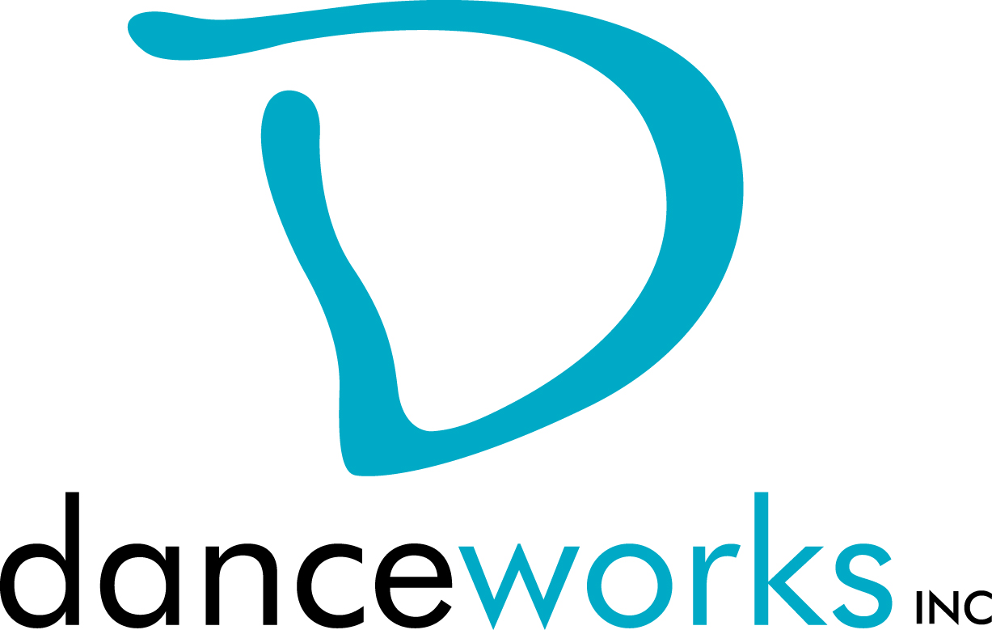

GET IT OUT THERE
Summer DanceLAB Series 2015
Call For Participation

Do you have work that you want to get out there? Would you like to get feedback on it? What about meeting other artists in hopes of collaborating? GET IT OUT THERE is a concert featuring new work created by Milwaukee performing artists from various disciplines. Selected artists will showcase their work on Saturday, June 6,2015 at Danceworks Studio Theatre. Danceworks provides production support including sound and minimal light design. This performance is presented through the DanceLAB concert series.

Interested artists are required to submit written proposals and biographical information to Danceworks on or before Wednesday, April 15, 2015 using the attached proposal form.

Accepted artists and their performing cast members will be eligible to take Danceworks studio classes for free from the date of acceptance through June 27, 2015. Limited studio space will also be available for rehearsals at no charge to artist up to 3 hours a week.

Accepted Artists will set up one “check in” rehearsal with the production manager as to determine show order and provide mentoring if requested.

Please contact Danceworks Artistic Manager, Kim Johnson for more information at kjohnson@danceworksmke.org or at (414) 277-8480 ext. 6018.

GET IT OUT THERE Timeline:
March 27 Call for Participation
April 15 Proposals due to Danceworks by 6:00pm
April 17 Artists receive notification regarding acceptance into
performance
June 5, 4:30-9:30pm Tech Rehearsal (each piece will need to attend one of the 40 minutes tech rehearsals)
June 6, 3:15pm Call for Performers
June 6, 4:00-5:30pm Dress Rehearsal
June 6, 7:10pm Call for Performers
June 6, 8:00pm Performance

GET IT OUT THERE SUMMER 2015 PROPOSAL FORM

Proposals are due on or before Wednesday, April 15, 2015 at 6:00pm. Please submit electronic or hard copy to Kim Johnson, c/o Danceworks, 1661 N. Water St., Milwaukee, WI 53202 or kjohnson@danceworksmke.org. Please contact Kim Johnson at (414) 277-8480 ext. 6018 with questions or concerns or via email at the email address listed above. Only artists whose proposals are submitted by the deadline will be considered. Artists will be notified of their acceptance into GET IT OUT THERE on or before Friday, April 17, 2015.

ELIGIBILITY:
Performing artists must be 18 years of age or older.

CRITERIA:
Work must be a minimum of 3 1/2 minutes and not greater than 10 minutes. Work must not consist of profanity or crude subject matter. Proposals must fit flexibly into project parameters (including limited rehearsal time and technical support).

INSTRUCTIONS:
Please respond to the items below to the best of your ability. In addition to completing this form, please attach a bio (75 words or less). Any supporting materials (work samples, etc.) can be dropped off or attached but are not required. The quality of the proposal will be taken into consideration.

ARTIST:

ADDRESS:

PHONE: EMAIL:

ART DISCIPLINE:

Number of performers: _______
Length of work:___________
Additional elements you’d like to mention (i.e. costume/set design):

Special requirements (if any):

What is the intention of your piece?

Why are you interested in being a part of this performance?

How did you find out about GET IT OUT THERE?

