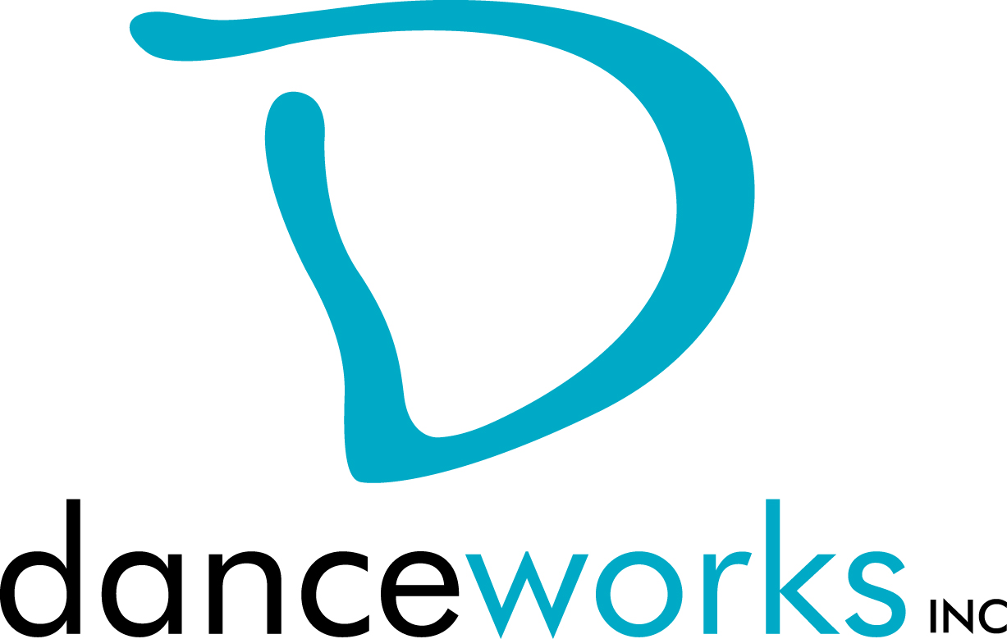
GET IT OUT THERE
DanceLAB Series 2018
Call For Participation

Do you have work that you want to get out there? Would you like to get feedback on it? What about meeting other artists in hopes of collaborating? GET IT OUT THERE is a concert featuring new work created by Milwaukee performing artists from various disciplines. Selected artists will showcase their work on Saturday, September 15, 2018 at Danceworks Studio Theatre. Danceworks provides production support including sound and minimal light design. This performance is presented through the DanceLAB concert series.

Interested artists are required to submit written proposals and biographical information to Danceworks on or before Monday, June 25, 2018, using the attached proposal form.

Accepted artists and their performing cast members will be eligible to take 2 Danceworks studio classes per week for free, with the exception of certain workshops, from the date of acceptance through September 29, 2018. Limited studio space will also be available for rehearsals at no charge to artist up to 3 hours a week.

Accepted artists presenting work for the first time in a DanceLAB concert are required to schedule a feedback session with the production manager. Accepted Artists that have participated in previous DanceLAB concerts may request mentoring from the production manager at any time during the creation/rehearsal process. All artists will be expected to submit a video link to show completed work, or work in-progress no later than Monday, August 27, 2018.

Please contact Danceworks Artistic Director, Dani Kuepper for more information at dkuepper@danceworksmke.org or at (414) 277-8480 ext. 6018.

GET IT OUT THERE Timeline (Danceworks reserves the right to edit the production schedule as needed.)
May 22 Call for Participation
June 25 Proposals due to Danceworks
June 29 Artists receive notification regarding acceptance into performance
August 27 Video submission of work and program notes due
September 7 Music submission due

September 9-13 Tech Rehearsal (each piece will need to attend 1,
25-minute tech)
September 14, 7:45 -10:00pm Mandatory Dress Rehearsal
September 15, 5:00pm Call for Performers
September 15, 6:00pm Performance #1
September 15, 8:00pm Performance #2

GET IT OUT THERE 2018 PROPOSAL FORM

Proposals are due on or before Monday, June 25, 2018. Please submit electronic or hard copy to Dani Kuepper, c/o Danceworks, 1661 N. Water St., Milwaukee, WI 53202 or dkuepper@danceworksmke.org. Please contact Dani Kuepper at (414) 277-8480 ext. 6018 with questions or concerns or via email at the email address listed above. Only artists whose proposals are submitted by the deadline will be considered. Artists will be notified of their acceptance into GET IT OUT THERE on or before Friday, June 29, 2018.

ELIGIBILITY:
Performing artists must be 18 years of age or older.

CRITERIA:
Work must be a minimum of 3 minutes and not greater than 10 minutes. Work must not consist of profanity, nudity, or crude subject matter. Proposals must fit flexibly into project parameters (including limited rehearsal time and technical support).

INSTRUCTIONS:
Please respond to the items below to the best of your ability. In addition to completing this form, please attach a bio (75 words or less). Any supporting materials (work samples, etc.) can be dropped off or attached but are not required. The quality of the proposal will be taken into consideration.

ARTIST:

ADDRESS:

PHONE: EMAIL:

ART DISCIPLINE:

BIO:

Number of performers: ____
Length of work:_____
Additional elements you’d like to mention (i.e. costume/set design):

Special requirements (if any):

What is the intention of your piece?

Any additional comments about you or your work:

Why are you interested in being a part of this performance?

How did you find out about GET IT OUT THERE?

